Rontala Pooja Reddy
2503B05130
M. Tech cse
Assignment-3

Task:1

Problem-01:
A bit stream 1101011011 is transmitted using the standard CRC method. The generator polynomial is x⁴+x+1. What is the actual bit string transmitted?
#include <bits/stdc++.h>
using namespace std;

// Performs bitwise XOR between two binary strings (a and b)
string findXor(string a, string b) {
int n = b.length();
string result = "";

// Compare each bit (skip first bit as per CRC standard)
for (int i = 1; i< n; i++) {
if (a[i] == b[i])
result += "0";
else
result += "1";
}
return result;
}

// Performs Modulo-2 division (CRC division algorithm)
string mod2div(string dividend, string divisor) {
int n = dividend.length();
int pick = divisor.length();
string tmp = dividend.substr(0, pick); // Initial window

while (pick < n) {
if (tmp[0] == '1')
// XOR with divisor and bring down next bit
tmp = findXor(divisor, tmp) + dividend[pick];
else
// XOR with zeros and bring down next bit
tmp = findXor(string(pick, '0'), tmp) + dividend[pick];
pick++;
}

// Final XOR step
if (tmp[0] == '1')
tmp = findXor(divisor, tmp);
else
tmp = findXor(string(pick, '0'), tmp);

return tmp;
}

// Appends CRC remainder to the original data
string encodeData(string data, string key) {
int n = key.length();
string paddedData = data + string(n - 1, '0'); // Append n-1 zeros
string remainder = mod2div(paddedData, key);
return data + remainder; // Return data + CRC
}

// Checks if received data has errors (remainder = 0)
int receiver(string code, string key) {
string remainder = mod2div(code, key);
return (remainder.find('1') == string::npos) ?1 : 0;
}

int main() {
string data = "1101011011";
string key = "10011";

cout<< "Sender Side" <<endl;
cout<< "Data: " << data <<endl;
cout<< "Key: " << key <<endl;
string code = encodeData(data, key);
cout<< "Encoded Data: " << code <<endl<<endl;

cout<< "Receiver Side" <<endl;
if (receiver(code, key))
cout<< "Data is correct (No errors detected)" <<endl;
else
cout<< "Data is incorrect (Error detected)" <<endl;

return 0;
}
Output:
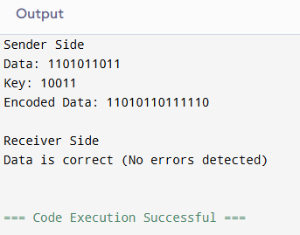

Task:2
Problem-02:
A bit stream 10011101 is transmitted using the standard CRC method. The generator polynomial is x³+1.

- What is the actual bit string transmitted?
- Suppose the third bit from the left is inverted during transmission. How will receiver detect this error?
1.ans
#include <bits/stdc++.h>
using namespace std;

// Performs bitwise XOR between two binary strings (a and b)
string findXor(string a, string b) {
int n = b.length();
string result = "";

// Compare each bit (skip first bit as per CRC standard)
for (int i = 1; i< n; i++) {
if (a[i] == b[i])
result += "0";
else
result += "1";
}
return result;
}

// Performs Modulo-2 division (CRC division algorithm)
string mod2div(string dividend, string divisor) {
int n = dividend.length();
int pick = divisor.length();
string tmp = dividend.substr(0, pick); // Initial window

while (pick < n) {
if (tmp[0] == '1')
// XOR with divisor and bring down next bit
tmp = findXor(divisor, tmp) + dividend[pick];
else
// XOR with zeros and bring down next bit
tmp = findXor(string(pick, '0'), tmp) + dividend[pick];
pick++;
}

// Final XOR step
if (tmp[0] == '1')
tmp = findXor(divisor, tmp);
else
tmp = findXor(string(pick, '0'), tmp);

return tmp;
}

// Appends CRC remainder to the original data
string encodeData(string data, string key) {
int n = key.length();
string paddedData = data + string(n - 1, '0'); // Append n-1 zeros
string remainder = mod2div(paddedData, key);
return data + remainder; // Return data + CRC
}

// Checks if received data has errors (remainder = 0)
int receiver(string code, string key) {
string remainder = mod2div(code, key);
return (remainder.find('1') == string::npos) ?1 : 0;
}

int main() {
string data = "10011101";
string key = "1001";

cout<< "Sender Side" <<endl;
cout<< "Data: " << data <<endl;
cout<< "Key: " << key <<endl;
string code = encodeData(data, key);
cout<< "Encoded Data: " << code <<endl<<endl;

cout<< "Receiver Side" <<endl;
if (receiver(code, key))
cout<< "Data is correct (No errors detected)" <<endl;
else
cout<< "Data is incorrect (Error detected)" <<endl;

return 0;
}
Output:

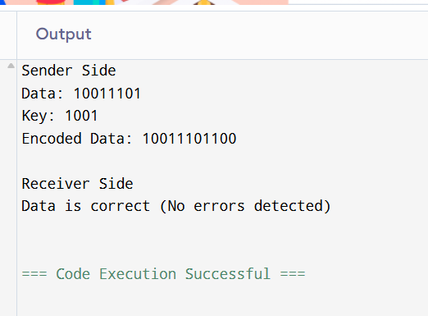

2.ans:
#include <iostream>
#include <string>
#include <cmath>
#include <algorithm>
using namespace std;
#define int long long int

// Function to convert integer to binary string
string toBin(int num) {

// Handle case when number is 0
if (num == 0) return "0";
string bin = "";
while (num) {
// Append '1' or '0' based on least significant bit
bin += (num & 1) ? '1' : '0';
// Shift right to process next bit
num = num >> 1;
}
// Reverse string since bits were added in reverse order
reverse(bin.begin(), bin.end());
return bin;
}

// Function to convert binary string to decimal integer
int toDec(string bin) {
int n = bin.size();

// Handle empty string
if (n == 0) return 0;
int num = 0;
for (int i = 0; i < n; i++) {
if (bin[i] == '1') {
// Compute power of 2 for each '1' in binary string
num += 1 << (n - i - 1);
}
}
return num;
}

// Function to compute CRC and print remainder and codeword
void CRC(string data, string key) {
int n = key.length();
if (n == 0) {
cout << "Error: Key cannot be empty" << endl;
return;
}

// Convert binary strings to decimal integers
// Generator polynomial (key)
int gen = toDec(key);

// Original data
int code = toDec(data);

// Append (n - 1) zeros to the data to make space for CRC bits
int dividend = code << (n - 1);

// Calculate the position to start XOR (most significant bit position)
int shft;
while ((shft = (int)log2(dividend) - n + 1) >= 0) {
// Extract top 'n' bits of dividend, XOR with generator polynomial
int rem = (dividend >> shft) ^ gen;

// Replace top bits in dividend with XOR result (remainder)
dividend = (dividend & ((1 << shft) - 1)) | (rem << shft);
}

// Final codeword is the original data with the remainder appended
int codeword = (code << (n - 1)) | dividend;

// Print results
cout << "Remainder: " << toBin(dividend) << endl;
cout << "Codeword : " << toBin(codeword) << endl;
}

signed main() {
string data = "10111101";
string key = "1001";
CRC(data, key);
return 0;
}
Output:
